Physics 1 Unit 3 – Forces Name: ___________________________

IB 2.2 Forces - Friction on an Incline

1. A 17.5 kg crate on a 23° incline is being pulled with a rope, parallel to the incline. The coefficients of friction are μd = 0.13 and μs = 0.32. a) What is the minimum force needed to keep the block from sliding down the incline.? b) What is the minimum force needed to just start the block moving up the incline? c) What force is needed to move the block at a constant speed up the incline? d) What force is needed to lower the block at a constant speed down the incline?

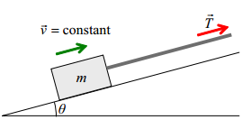

1. Block A has a mass of 3.50 kg and the incline angle is 40. The incline has a coefficient of dynamic friction of 0.23 and a coefficient of static friction of 0.35. The pulley is frictionless and massless. a) What is the maximum mass of block B and the corresponding tension in the cord when block A is at rest? b) What is the minimum mass of block B and the corresponding tension in the cord when block A is at rest? c) What is the mass of block B and the tension in the cord if block A is moving at a constant velocity up the incline and d) moving at a constant velocity down the incline.

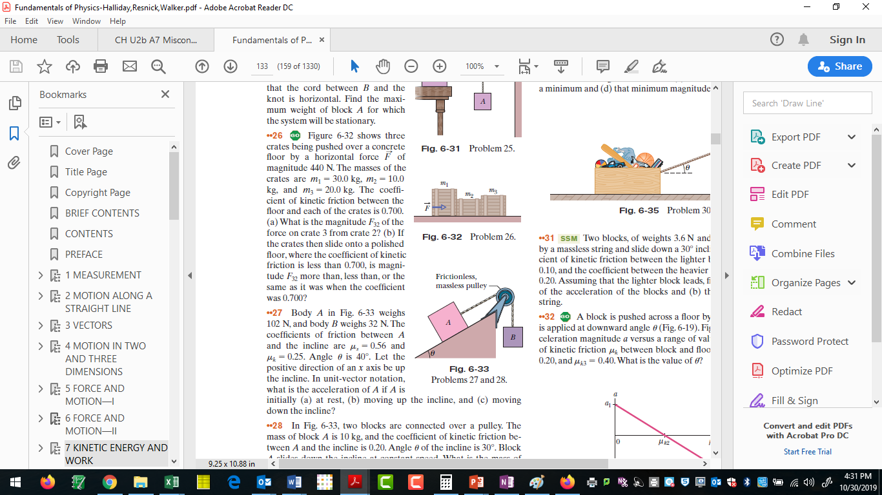

1. A 7.50 kg mass 1 and a 9.50 kg mass 2 on a 30° incline are connected over a pulley to a larger 12.0 kg mass M. What is a) magnitude and direction of the acceleration of the system b) the tension T1 between m1 and m2 and c) the tension T2 between m2 and M. The coefficients of friction are μd = 0.18 and μs = 0.24.

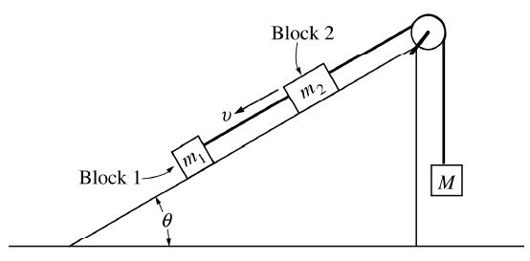

1. A 3.5 kg block is launched up a 15° incline at 4.65 m/s. If the coefficient of static friction is 0.37 and the coefficient of dynamic friction is 0.21, what happens? There are two options: A: Either the block slides up the incline some distance only to stop at that point, resting on the slope, OR B: The block slides up the incline some distance to turn around and slide back down.

If option A happens, determine a) the distance the block moves up the slope, and b) the force of static friction once it stops. If option B happens, determine a) the distance the block moves up the slope, and b) the speed of the block when it reaches the bottom of the slope once again.

1. Two blocks are connected by a string. One rests on a 30° incline while the other is a freely hanging mass. The coefficients of friction between the block on the slope and the incline surface are μs = 0.24 and μd = 0.11. If the mass on the incline is 2.50 kg, what does the hanging mass need to be to a) have the block sliding down the incline with an acceleration of 1.5 m/s2, b) have the system accelerating to the right at 1.5 m/s2. Determine the tension in the string for each case.

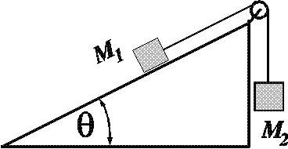

1. Three masses are connected by strings as shown below. m1 on the 30° incline is 3.50 kg, m2 on the surface is 5.75 kg and the hanging m3 is 1.15 kg. If the coefficients of static and dynamic friction are μs = 0.45 and μd = 0.28, what is happening? If the system is at rest, determine the forces of static friction on m1 and m2 , and the tensions in the two cords (T1 connects masses 1 and 2, while T2 connects masses 2 and 3.) If the system is moving, determine the acceleration of the system and the two tensions.